Introduction to Ecology | Adapted from http://www.marsd.org/cms/lib7/NJ01000603/Centricity/Domain/299/Lab%20Bio%20ch%202.ppt
Ecology is the study of ecosystems.
Ecosystems
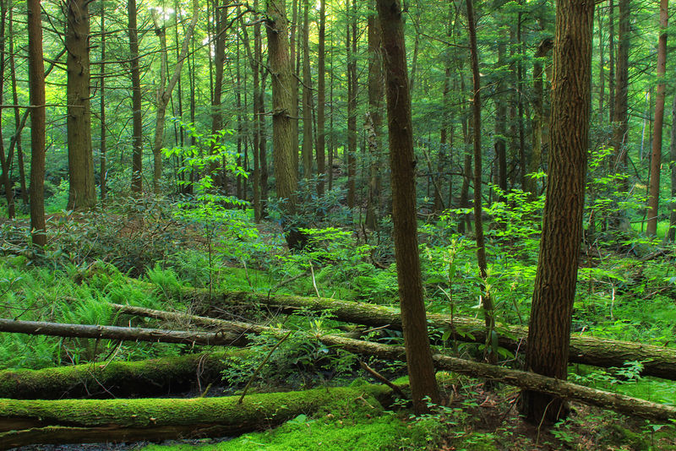 | What nonliving things are essential for life?  Living organisms cannot exist without the nonliving aspects of the environment. For example: air, water and sunlight, which are all nonliving, are all essential to living organisms. Both nonliving and living things make up an ecosystem.
What is an Ecosystem?
An ecosystem consists of all the parts, living and nonliving, that interact in the same habitat. Living organisms include all the species of plants, animals, and fungi, as well as micro-organisms. Nonliving considerations include:
- Climate
- Latitude (distance from the equator)
- Elevation
- Soil composition
- Pollution
You can find an ecosystem in a large body of fresh water or in a small aquarium. You can find an ecosystem in a large thriving forest or in a small piece of dead wood. Examples of ecosystems are as varied as rainforest, savanna, tundra, or desert. | 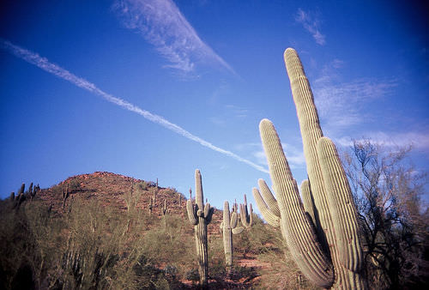
Ecosystems and Energy
Ecosystems need energy. Ecosystems mostly get their energy in the form of sunlight. This energy then flows through the ecosystem, passed from organism to organism.
Bears get their energy from their food. Brown bears eat a varied diet, from nuts and berries to fish and other animals. When bears eat a berry, they are obtaining energy that the plant originally captured from the sun. Even when a bear eats another animal, the energy in that animal ultimately came from eating a producer that captured the sun's energy. | 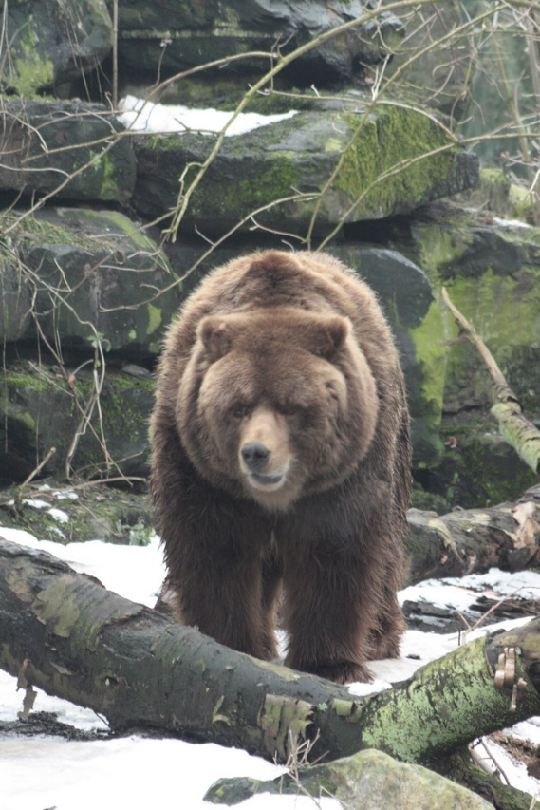
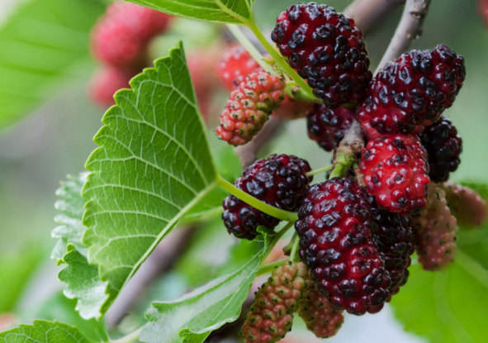

Energy is the ability to do work. In organisms, this work can be physical work, like walking or jumping, or it can be the work used to carry out the chemical processes in their cells. Every biochemical reaction that occurs in an organism's cells needs energy. All organisms need a constant supply of energy to stay alive.
Some organisms can get the energy directly from the sun. Some organisms get their energy by consuming other organisms. Through predator-prey relationships, the energy of one organism is passed on to another. Energy is constantly flowing through a community. With just a few exceptions, all life on Earth depends on the sun’s energy for survival.
The energy of the sun is first captured by producers, organisms that can make their own food. Many producers make their own food through the process of photosynthesis. The "food" the producers make is the sugar, glucose. Producers make food for the rest of the ecosystem. As energy is not recycled, energy must consistently be captured by producers. This energy is then passed on to the organisms that eat the producers, and then to the organisms that eat those organisms, and so on.
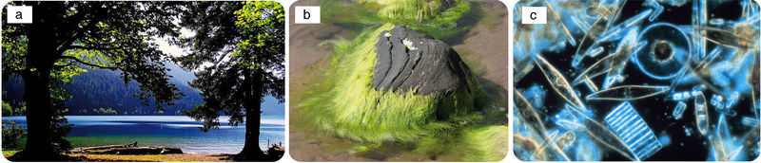
Producers include (a) plants, (b) algae, and (c) diatoms.
The only ingredients needed for photosynthesis are sunlight, carbon dioxide (CO₂), and water (H₂O). From these simple ingredients, plants produce the simple sugar glucose (C₆H₁₂O₆). In many plants this can also be converted to more complex carbohydrates such as starches. These producers change energy from sunlight into chemical energy. They are also make oxygen as a byproduct.
The survival of every ecosystem is dependent on the producers. Without producers capturing energy from the sun, an ecosystem could not exist. On land, plants are the dominant producers.
Phytoplankton, tiny organisms that can perform photosynthesis, are the most common producers in the oceans and lakes. Algae, which forms the green layer you might see floating on a pond, are an example of phytoplankton. There are also bacteria that use chemical processes instead of sunlight to produce food. Common in some marine ecosystems without sunlight, they are still producers.
Consumers and Decomposers
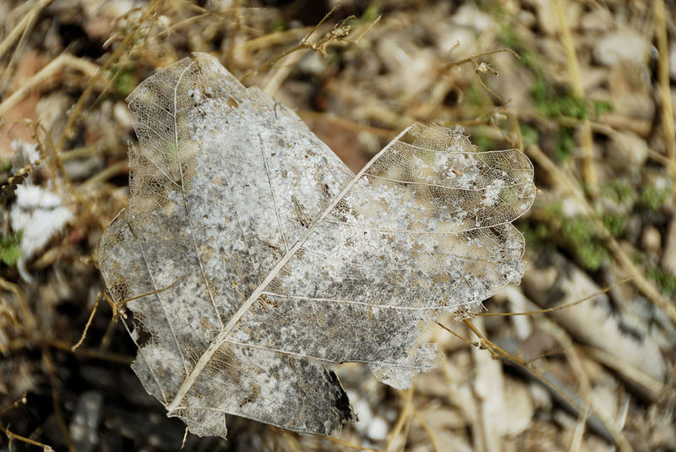 | What is breaking down this leaf?  Notice how this leaf is slowly being broken down. This process can be carried out by fungi and bacteria on the ground. Breaking down old leaves is an important process since it releases the nutrients in the dead leaves back into the soil for living plants to use.
Producers make their own food through photosynthesis. Many organisms are not producers and cannot make their own food. So how do these organisms obtain their energy? They must get their energy from other organisms. They must eat other organisms, or obtain their energy from these organisms some other way. The organisms that obtain their energy from other organisms are called consumers. All animals are consumers, and they eat other organisms.
The consumers can be placed into different groups, depending on what they consume.
- Herbivores are animals that eat producers. For example, caterpillars, rabbits and deer are herbivores that eat plants. Animals that eat phytoplankton in aquatic environments are also herbivores.  - Carnivores feed on animals, either herbivores or other carnivores. Snakes that eat mice are carnivores. Hawks that eat snakes are also carnivores. | 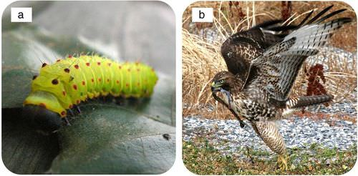  Examples of consumers are caterpillars (herbivore) and hawks (carnivore).
- Omnivores eat both producers and consumers. Most people are omnivores, since they eat fruits, vegetables, and grains from plants, and also meat and dairy products from animals. Dogs, bears, and raccoons are also omnivores.

Decomposers and Stability
Decomposers get nutrients and energy by breaking down dead organisms and animal wastes. Through this process, decomposers release nutrients, such as carbon and nitrogen, back into the environment. These nutrients are recycled back into the ecosystem so that the producers can use them. They are passed to other organisms when they are eaten or consumed. Many of these nutrients are recycled back into the soil, so they can be taken up by the roots of plants.

The stability of an ecosystem depends on the actions of the decomposers. Examples of decomposers include mushrooms on a decaying log. Bacteria in the soil are also decomposers. Imagine what would happen if there were no decomposers. Wastes and the remains of dead organisms would pile up and the nutrients within the waste and dead organisms would not be released back into the ecosystem. Producers, on which all other organisms depend, would not have enough nutrients.
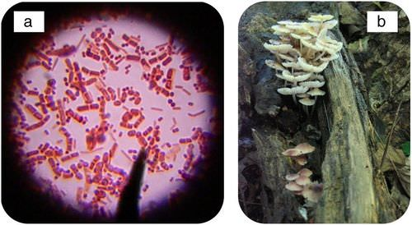
Examples of decomposers are (a) bacteria and (b) fungi.
Food Chains and Food Webs
Food chains show the eating patterns in an ecosystem. Food energy flows from one organism to another. Arrows are used to show the feeding relationship between the animals. The arrow points from the organism being eaten to the organism that eats it. For example, an arrow from a plant to a grasshopper shows that the grasshopper eats the plant. Energy and nutrients are moving from the plant to the grasshopper. Next, a bird might prey on the grasshopper, a snake may eat the bird, and then an owl might eat the snake. The food chain would be:  plant → grasshopper → bird → snake → owl | 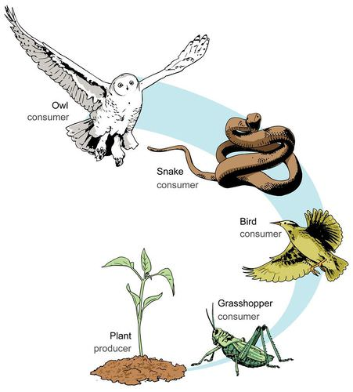
Feeding relationships in most ecosystems are complicated, so we can combine food chains together into a food web to show a more accurate flow of energy.
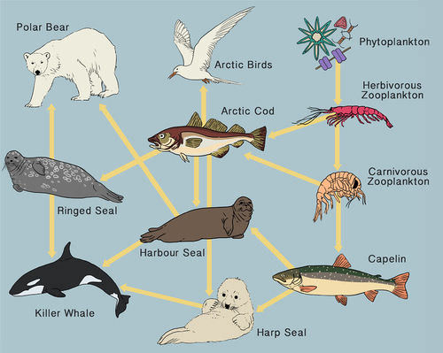
Food web in the Arctic Ocean.
Energy Pyramids
If the cheetah is successful in capturing the warthog, it would gain some energy by eating it. But would the cheetah gain as much energy as the warthog has ever consumed? No, the warthog has used up some of the energy it has consumed for its own needs. The cheetah will only gain a fraction of the energy that the warthog has consumed throughout its lifetime. | 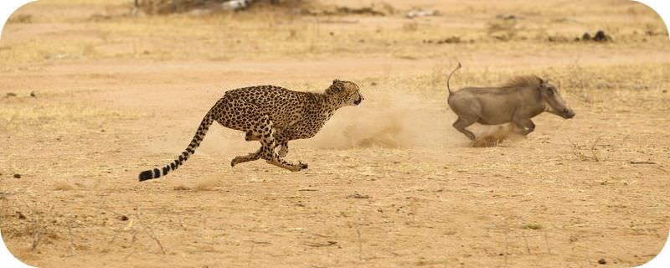
Plants are producers, bringing energy into the ecosystem by converting sunlight into glucose. Does the plant use some of the energy for its own needs? Of course it needs and uses energy.
When an herbivore eats a plant, only about 10% of the total energy from the plant gets stored in the herbivore’s body as extra body tissue. The rest of the energy is used by the herbivore. The next consumer on the food chain that eats the herbivore will only store about 10% of the total energy from the herbivore in its own body. This means the carnivore will store only about 1% of the total energy that was originally in the plant. In other words, only about 10% of energy of one step in a food chain is stored in the next step in the food chain. The majority of the energy is used by the organism or released to the environment.
Every time energy is transferred from one organism to another, there is a loss of energy. This loss of energy can be shown in an energy pyramid. Since there is energy loss at each step in a food chain, it takes many producers to support just a few carnivores in a community.
Plants are found on the first level of the pyramid. The next level will be the herbivores, and then the carnivores that eat the herbivores.
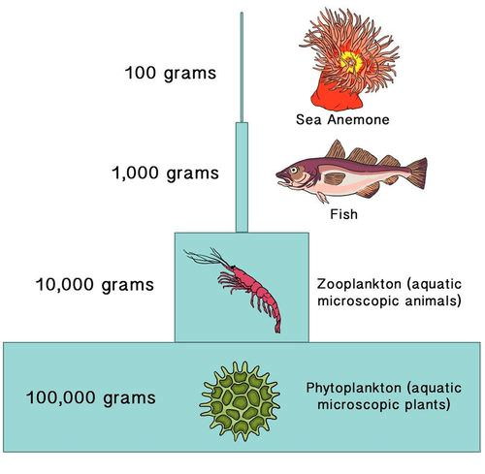
As illustrated by this ecological pyramid, it takes a lot of phytoplankton to support the carnivores of the oceans.
Ecosystems and Nutrients
Energy flows through an ecosystem. Ultimately, energy enters planet earth as sunlight, and leaves as heat radiated into space. But water and elements like carbon and nitrogen are recycled. Nutrients such as water, carbon, and nitrogen are constantly being recycled through the environment.
The Water Cycle
Water is recycled constantly through the ecosystem.
Water is obviously an extremely important aspect of every ecosystem. Life cannot exist without water. Many organisms contain a large amount of water in their bodies, and many live in water, so the water cycle is essential to life on Earth. Water continuously moves between living organisms, such as plants, and non-living things, such as clouds, rivers, and oceans.
The water cycle does not have a starting or ending point. It is an endless process that involves the oceans, lakes and other bodies of water, as well as the land surfaces and the atmosphere.
- Water evaporates from the surface of the oceans, leaving behind salts. As the water vapor rises, it collects and is stored in clouds.  - As water cools in the upper atmosphere, it condenses into clouds.  - Further condensation creates precipitation in the form of rain, snow, hail, and sleet. This allows the water to return again to the Earth’s surface.  - When precipitation lands on land, the water can sink into the ground to become part of our underground water reserves known as groundwater. | 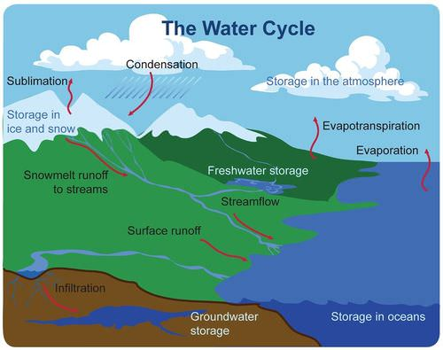

Run-off
Most precipitation that occurs over land, however, is not absorbed by the soil and is called runoff. This runoff collects in streams and rivers and eventually flows back into the ocean.

Transpiration
Water also moves through the living organisms in an ecosystem. Plants soak up large amounts of water through their roots. The water then moves up the plant and evaporates from the leaves in a process called transpiration. The process of transpiration, like evaporation, returns water back into the atmosphere.
The Carbon Cycle
Energy and matter cannot be created. Energy is flowing into planet Earth from the Sun, but all the matter we will ever have is what is already here on earth.
Carbon is one of the most common elements, but animals can’t eat coal (which is over 75% carbon). Plants can’t consume pure carbon either, but, unlike animals, plants can consume carbon dioxide.
And the air has plenty of carbon dioxide, right?
Actually, air is only $1/24$ of 1% carbon dioxide. And if it were much more we’d be sick. And, as is becoming increasingly apparent, way before that happened our planet would undergo drastic climate changes. At the extreme, Earth could become like Venus – maybe not around 900 degrees – we’re further from the Sun, but way too warm for us to survive.
Carbon is constantly cycling between living organisms and the atmosphere. In the atmosphere, carbon is in the form of carbon dioxide gas (CO₂). Plants take in carbon dioxide and convert it to glucose (C₆H₁₂O₆) through the process of photosynthesis. Then as animals eat plants or other animals, they gain the carbon from those organisms.
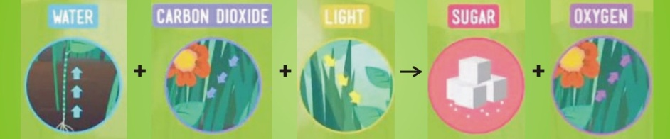
How does this carbon in living things end up back in the atmosphere? We breathe out carbon dioxide. This carbon dioxide is generated through the process of cellular respiration. Our bodies essentially burn food for energy, and this chemical reaction releases carbon dioxide. We, like all animals, exhale carbon dioxide and return it back to the atmosphere. Also, carbon is released to the atmosphere as an organism dies and decomposes.
Carbon is also released to the atmosphere as the result of burning plant matter and fossil fuels, which our modern civilization does in very large quantities.
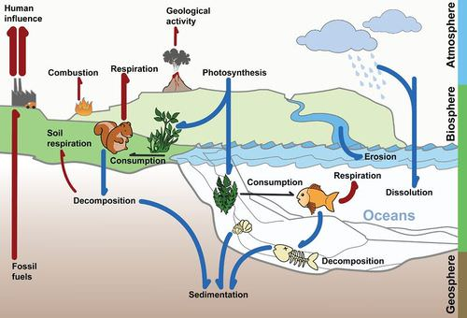 | The carbon cycle.  The cycling of carbon dioxide in photosynthesis and cellular respiration are main components of the carbon cycle. Carbon is also returned to the atmosphere by the burning of organic matter and fossil fuels, and by the decomposition of organic matter.
Fossil Fuels
Millions of years ago, there were so many dead plants and animals that they could not completely decompose before they were buried. They were covered over by soil or sand, tar or ice. These dead plants and animals are organic matter made out of cells full of carbon-containing organic compounds. When organic matter is under pressure for millions of years, it forms fossil fuels. Fossil fuels are coal, oil, and natural gas.
The burning of fossil fuels releases more carbon dioxide into the atmosphere than is used by photosynthesis. So, there is more carbon dioxide entering the atmosphere than is coming out of it. Carbon dioxide is known as a greenhouse gas, since it lets in light energy but does not let heat escape, much like the panes of a greenhouse. The increase of greenhouse gases in the atmosphere is contributing to a global rise in Earth’s temperature, known as global warming or climate change.
 | Human activities like burning gasoline in cars are contributing to a global change in our climate.
The Oxygen Cycle
When plants perform photosynthesis they produce oxygen. Animals breathe in oxygen and exhale carbon dioxide.  Mostly that’s it. But plants also take in oxygen. Still they produce more oxygen than they use.  And there’s a little more to it. Of course there’s human activity (burning fuels) and naturally-occurring fires, which consume oxygen. And the weathering of certain minerals found in rocks frees up some oxygen to the atmosphere.  But most of our atmospheric oxygen (and the removal or carbon dioxide) comes from photosynthesis. And, while land plants perform a significant role, the biggest contribution is from phytoplankton. | 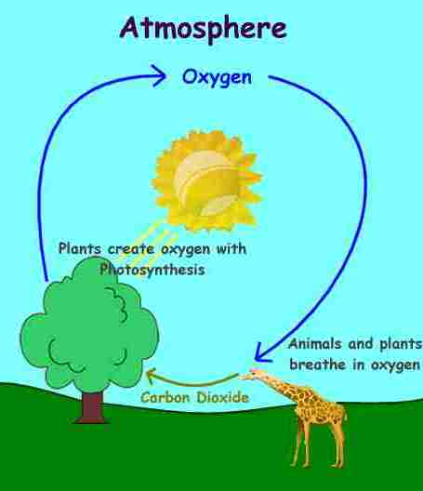
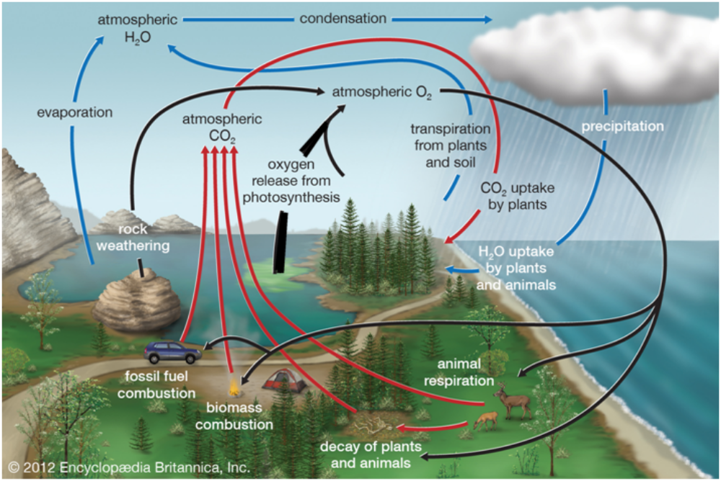
The black arrows show the oxygen flow. The red arrows show carbon dioxide.
The Nitrogen Cycle
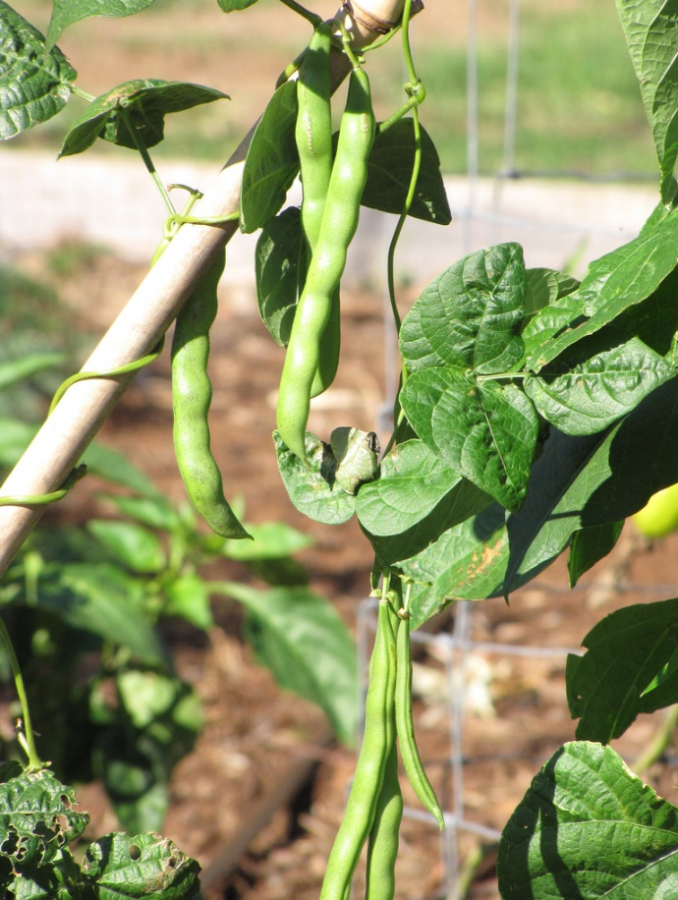 | 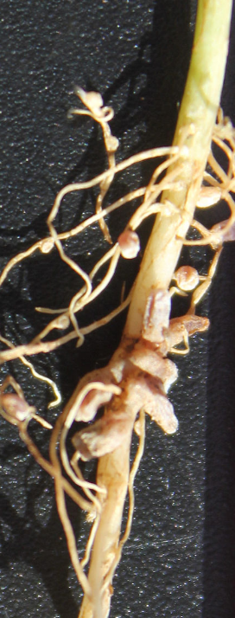  Nitrogen-fixing nodules on a clover root. | What can bean plants do that most other plants can't?  No, they don't grow giant stalks to the clouds.  Bean plants and other legumes (plants that have their seeds in pods) can use the nitrogen in the air to grow. It takes the help of special bacteria friends in the soil, and this relationship is unique to the legumes.  Nitrogen is the most commonly limiting nutrient in plants. Legumes use nitrogen fixing bacteria, specifically symbiotic rhizobia bacteria, within their root nodules to counter the limitation.  Rhizobia bacteria convert nitrogen gas (N2) to ammonia (NH3) in a process called nitrogen fixation. The plant root cells convert sugar into organic acids which then supply to the rhizobia in exchange.
Like water and carbon, nitrogen is also repeatedly recycled through the biosphere. This process is called the nitrogen cycle. Nitrogen is important for creating both proteins and nucleic acids like DNA. The air that we breathe is mostly nitrogen gas (N2), but, unfortunately, animals and plants cannot use the nitrogen when it is a gas. In fact, plants often die from a lack of nitrogen even though they are surrounded by plenty of nitrogen gas. Nitrogen gas (N2) has two nitrogen atoms connected by a very strong triple bond. Most plants and animals cannot use the nitrogen in nitrogen gas because they cannot break that triple bond. Bacteria play a very important role in the nitrogen cycle.
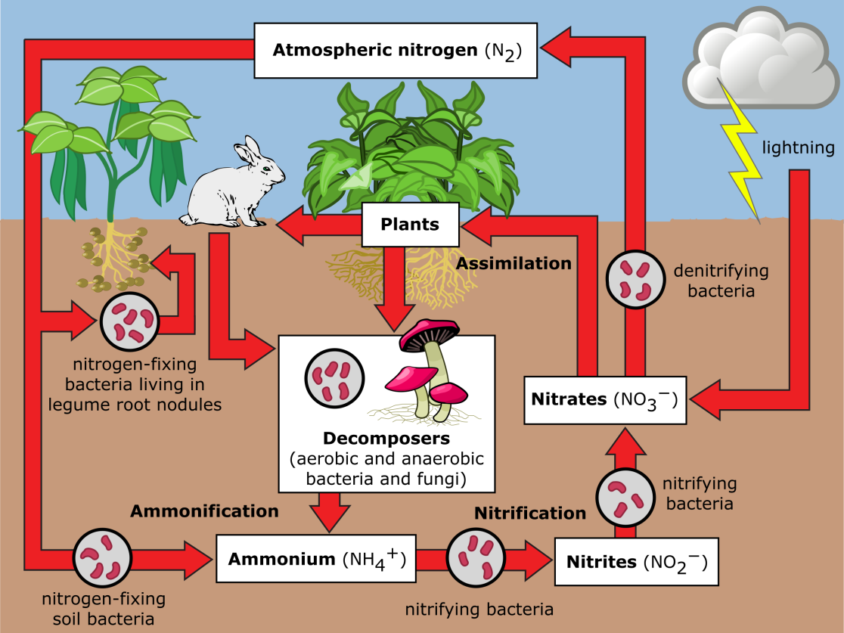
In order for plants to make use of nitrogen, it must be transformed into molecules they can use. This can be accomplished several different ways.  - Lightning: When lightening strikes, nitrogen gas is transformed into nitrate (NO₃⁻) that plants can use.  - Nitrogen fixation: Special nitrogen-fixing bacteria can also transform nitrogen gas into useful forms. These bacteria live in the roots of plants in the pea family. They turn the nitrogen gas into ammonium (NH₄⁺). In water environments, bacteria in the water can also fix nitrogen gas into ammonium. Ammonium can be used by aquatic plants as a source of nitrogen. | 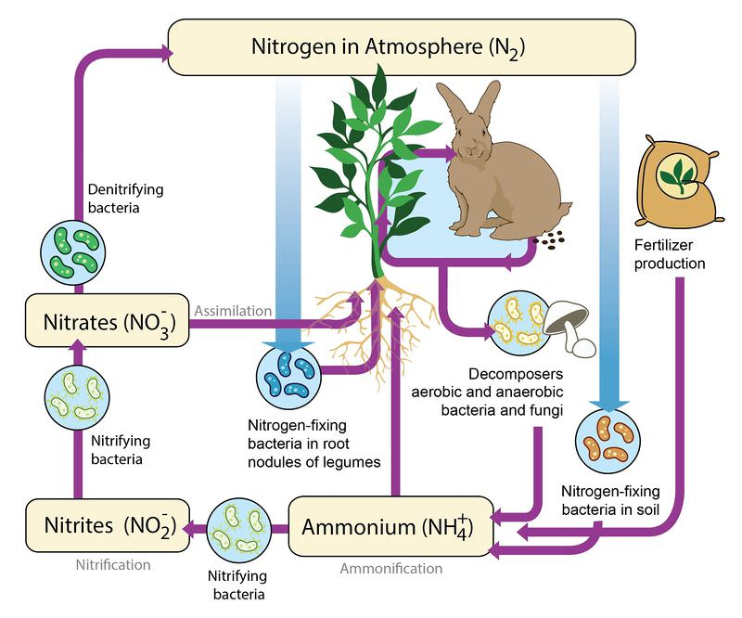  The nitrogen cycle includes assimilation, when plants absorb nitrogen; nitrogen-fixing bacteria that make the nitrogen available to plants in the form of nitrates; decomposers that transform nitrogen in dead organisms into ammonium; nitrifying bacteria that turn ammonium into nitrates; and denitrifying bacteria that turn nitrates into gaseous nitrogen.
- Nitrogen also is released to the environment by decaying organisms or decaying wastes. These wastes release nitrogen in the form of ammonium.
Ammonium in the soil can be turned into nitrate by bacteria. In the form of nitrate, nitrogen can be used by plants. It is then passed along to animals when they eat the plants.

Sending Nitrogen back to the Atmosphere
Turning nitrate back into nitrogen gas happens through the work of other (“denitrifying”) bacteria. These bacteria often live in swamps and lakes. They take in the nitrate and release it back to the atmosphere as nitrogen gas.

